Dear Team,

Based on the BM’s confirmation, we have updated the amount under “General Advance Recovered.”
Due to this adjustment, you will now see a closing cash balance difference of ₹3,360.

Kindly add ₹3,360 to the closing cash, as this amount was not accounted earlier and is currently kept in the locker.

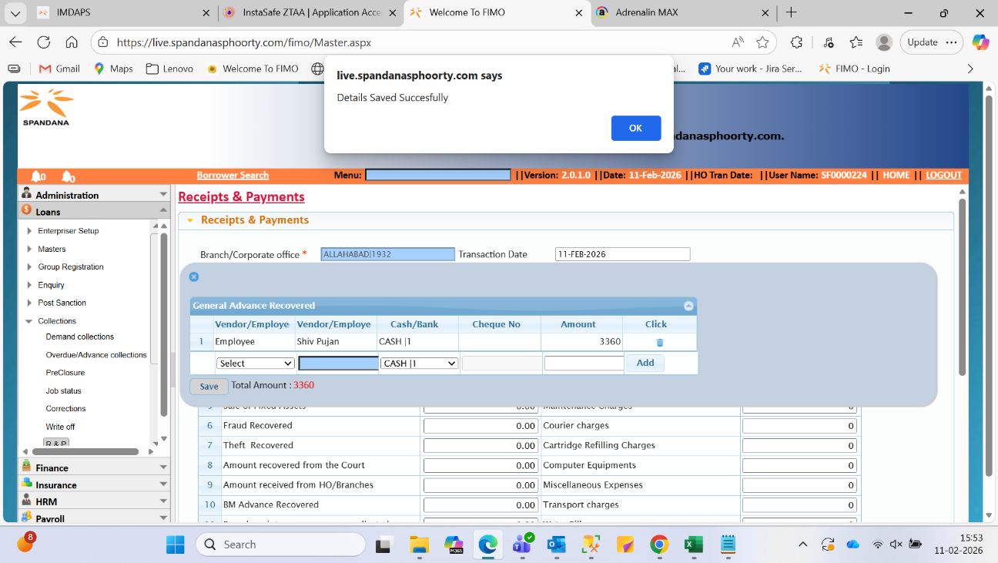

Bala Joseph Perikala
Senior Manager | Business Analytics & Planning
M:9391392159
Spandana Sphoorty Financial Limited
Galaxy Wing B, 16th Floor, Opp IKEA, Hyderabad - 500081


Integrity | Collaboration | Agility | Receptiveness | Empathy

From: Ram Kumar N <ram.kumar@spandanasphoorty.com>
Sent: 11 February 2026 16:08
To: Saptarshi Sankar Bose <saptarshisankar.bose@spandanasphoorty.com>; Bala Joseph Perikala <joseph.perikala@spandanasphoorty.com>; Mohit Kishore Prasad <mohit.kishoreprasad@spandanasphoorty.com>; Dharmendra Kumar Gupta <dharmendrakumar.gupta@spandanasphoorty.com>; Ajay Gautam <ajay.gautam@spandanasphoorty.com>; Shanker Sangam <shanker.sangam@spandanasphoorty.com>
Cc: Vipin Yadav <vipin.yadav@spandanasphoorty.com>; Aman Kumar Pathak <aman.pathak@spandanasphoorty.com>; Dushyant Kumar <dushyant.kumar@spandanasphoorty.com>; Vishvendra Singh <vishvendra.singh@spandanasphoorty.com>; Sri Ram Sharma <sriram.sharma@spandanasphoorty.com>; G Parthasarathy <parthasarathy.g@spandanasphoorty.com>; Prashant Rai <prashant.rai@spandanasphoorty.com>; Ramesh Allaparthi <ramesh.allaparthi@spandanasphoorty.com>; Sunand Sahu <sunand.sahu@spandanasphoorty.com>; FRM HO <frm@spandanasphoorty.com>; Ganesh KV <ganesh.kv@spandanasphoorty.com>; Deepak Kumar Nema <deepakkumar.nema@spandanasphoorty.com>; Jay Kumar Gour <jaykumar.gour@spandanasphoorty.com>
Subject: Re: Reg: Immediate Action Required: Closure of Low-Value Fraud Cases (< ₹30K)

Why BM Vishal Singh has not deposited the recovered money from customer in the month of Jan'26,why it took 3 years to collect this money and till today it is not accounted & posted.

We have already given a FGL posting to customer account, now why is the recovery money kept in locker by BM without accounting?

This is not clear for me yet?

How customer again appeared in OD recently, as I A has raised too.?

Thank you,

With Regards,

N.Ramkumar.
Head – Fraud Risk Management.
Mbl.:7075767069
HO, Spandana Sphoorty Financial Limited
Galaxy Wing B, 16th Floor, Opp IKEA, Hyderabad - 500081

Integrity | Collaboration | Agility | Receptiveness | Empathy
 " Save paper, save the Environment "

